

PRESS RELEASE Prague, 29th June 2016

BB Centrum tenants compete for BB C CUP

PASSERINVEST GROUP, the developer of the BB Centrum complex in Prague 4, organised the 16th annual football tournament between the tenants for the BB C Cup. This year football legends Antonín Panenka and Karol Dobiaš handed over the winning cup to MARS’ team. The top scorer of the tournament was Petr Janovský from Microsoft.

PASSERINVEST GROUP, the leading Czech investment and development company, does not only take care of its tenants on a professional level, but it also prepares various informal gatherings, like on the football pitch.

Teams from MARS, Microsoft, MONETA Money Bank (formerly GE Money Bank), Balance Club Brumlovka, PASSERINVEST GROUP, D. A. S, O2 Czech Republic and Savencia Fromage & Dairy Czech Republic competed against each other at this traditional tournament. The winner and possessor of the challenge BB C CUP was MARS, with Microsoft coming in second and MONETA Money Bank (formerly GE Money Bank) third. Petr Janovský from Microsoft scored the most goals in the tournament and Nikola Kubalová from PASSERINVEST GROUP obtained the congeniality award.

BB Centrum’s social networks are also full of football. In honour of the largest football festivity, EURO 2016, it has organised a photographic competition “CHEERING FOR FOOTBALL” on its Facebook profile: http://www.facebook.com/BBCentrum. Competitors can send their photographs with a football theme by message or comment until 10 July. The patrons of the competition are Antonín Panenka and Karol Dobiaš.

BB Centrum is one of the largest and most successful development projects in the Czech Republic. But it is not just an office centre – BB Centrum comprises a multifunctional complex with all the civic amenities, offering job and living opportunities, leisure activities, education and also cultural events. This year BB Centrum has already seen a children’s day, the concert of Olympic and Brouci
Band - The Beatles Revival, the second BookBooth was opened and at the end of August there will be CinemaBus stop here for a number of days.

You can find news and current information on the events in BB Centrum at http://www.facebook.com/BBCentrum.

You can find more photographs and videos from the BB C CUP on BB Centrum’s Facebook pages.

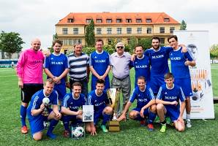

MARS’ winning team with football legends Antonín Panenka and Karol Dobiaš

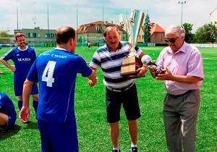

The MARS team accepts the challenge cup from Antonín Panenka and the trophy for 1st place in the BB C CUP tournament from Karol Dobiaš

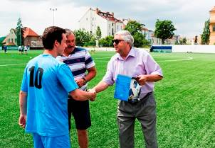

From left: top scorer of the tournament Petr Janovský, Microsoft, Antonín Panenka, Karol Dobiaš

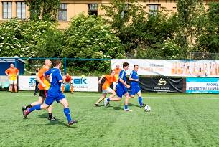

Shot of match between PASSERINVEST GROUP and MARS

For more information and photographs in print quality please contact:

Kristýna Samková, Head of Marketing and PR
PASSERINVEST GROUP, a.s.
Tel.: (+420) 221 582 111, fax: (+420) 222 515 521
Mobil: (+420) 602 186 708
E-mail: Kristyna.Samkova@Passerinvest.cz
www.passerinvest.cz, www.bbcentrum.cz

Marcela Štefcová
Crest Communications a.s.
Tel.: (+420) 222 927 125
Mobile: (+420) 731 613 669
E-mail: marcela.stefcova@crestcom.cz
www.crestcom.cz

ABOUT THE DEVELOPER

PASSERINVEST GROUP, a. s., is a purely Czech development company, whose name is primarily connected with the construction of the multifunctional BB Centrum complex in Prague 4 – Michle. The company, founded in 1991 by Radim Passer, built a very good name on both a domestic and international level with this, the most successful and extensive Czech project of its kind. This is not only due to the quality of the implemented projects and the high level of provided services, but also to a sense of fair play, an accommodating relationship with the tenants/users of the buildings and the responsibility towards society and the environment. PASSERINVEST GROUP also has other interesting development projects in its portfolio.

